Student Assessment Submission and Declaration
When submitting evidence for assessment, each student must sign a declaration confirming that the work is their own.
Student name:Adel Shurab  21023153 |  | Assessor name:  Dima Taha
Issue date:31-March-2022 | Submission date:2/6/2022 |  | Submitted on:  2/6/2022
Programme: Higher National Diploma in Computing
Unit: Unit 3: Professional Practice
Assignment number and title: Planning a Training Event and Continuous Professional Development (CPD)
Part one
QA
- Our topic is telemarketing. We talk about the importance of telemarketing at the present time, its advantages and its assistance to companies in the field of sales and events, which we see. This topic will be explained in detail through a PowerPoint file that was prepared by the work team. A representative scene for the audience to show how to work in telemarketing And the activities that we will present during the event are a video presentation that briefly explains our topic, and another activity is an experiment, which is called sell me this, which is something that is given to students to sell to each other and also ask some questions to the students.
2-https://alqudscollege-my.sharepoint.com/:f:/g/personal/21023153_student_ltuc_com/El6jcRVXGaNEjp6iUr7DNGkBGYlMmO_Kl0iW_3JwWWHhqQ?e=xqRljI
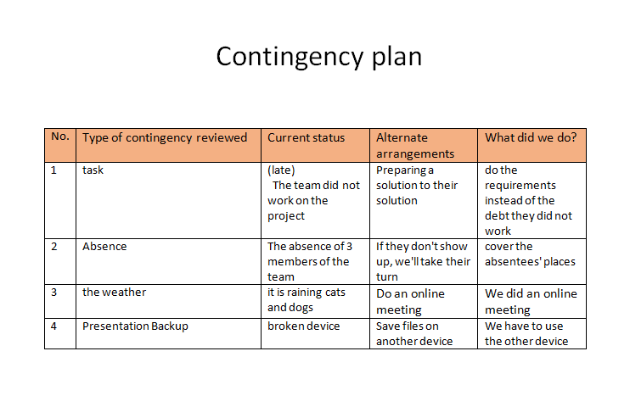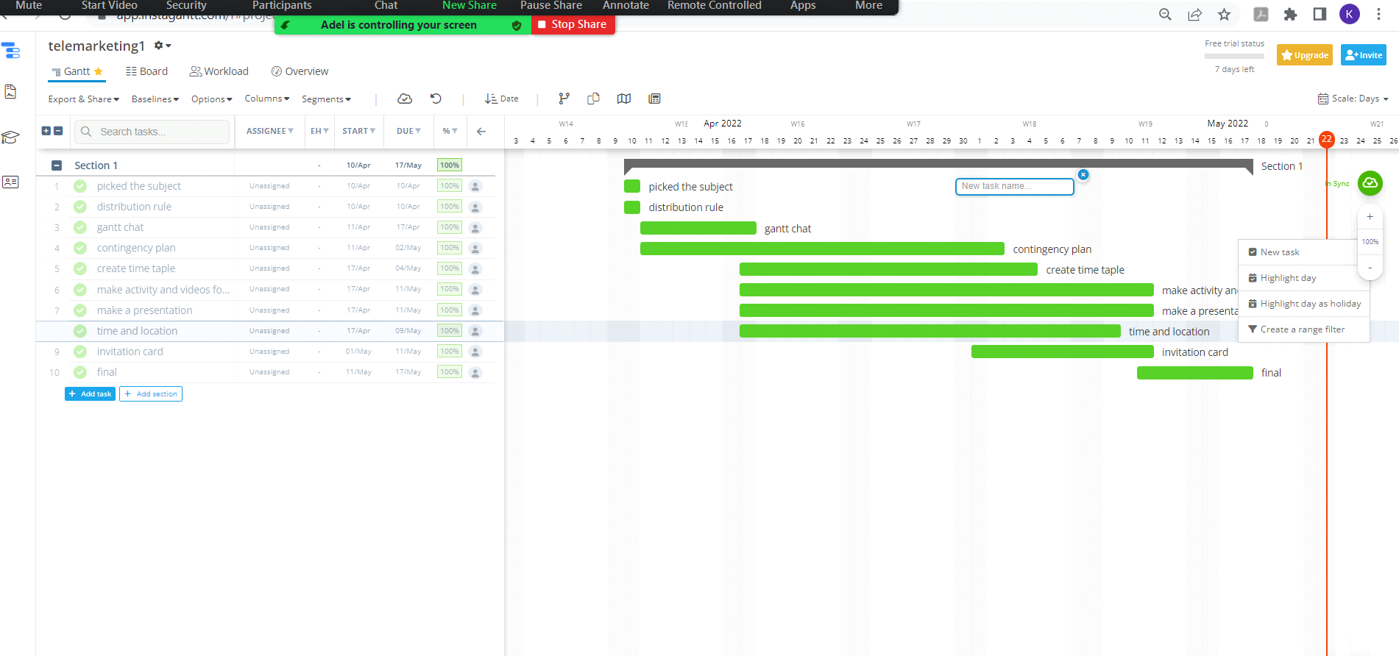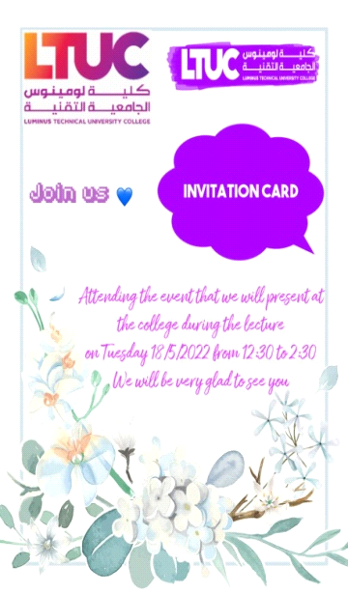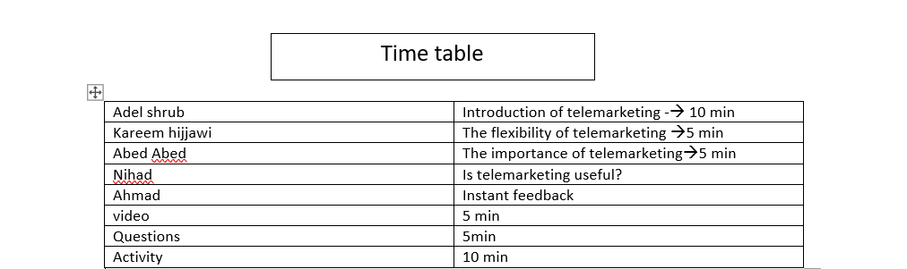
3- We learned some skills such as time management, so now we are able to manage our time and business easily because we learned and worked with them during the project and also learned to solve problems and now we are able to think well of solutions to the problems that we may face in life, that is, by highlighting more than one solution to control any problem
4-What is the definition of team dynamics :
The methods you engage with other members of your team at work are defined by team dynamics. Such professional partnerships are built on mutual trust and respect. If you want to reach organizational goals, you must get along with your team members.
The four steps for team dynamics :
1- Forming
2- Storming
3- Norming
4- Performing
In each step we divide the steps to each other :
Adel : forming
Kareem: storming
Abed : norming
Ahmad : performing
The advantages of team dynamics :
1- Shared purpose
2- Trust and openness
3- Diversity and inclusion
4- Interdependence and sense of belonging
5- Participative leadership
QB
1-
Interpersonal skills are skills that we use every day when we communicate with other people, both individually and collectively. They include a wide range of skills, including the ability to control and manage your emotions but especially communication skills such as effective speaking and listening.
Skills I used while designing: communication skills : I communicated with my team through meetings, interviews, whatsApp messages and phone calls Where I listen to them and they listen to me and I give them a feedback and they give me a feedback.
Skills I used while delivery : problem solving: When the team members were late to the event and did not know what they would do, I would tell them what to do and when they were absent from the event, and I expected this by 90%, I was making a plan to cover their place so that their absence would not affect the event
2- I made a plan for the event by means of a Gantt chart, where I made a schedule and put everything that was required of me, I put the start and end time, I worked on each step by step, I solved every problem I encountered at each step
a- I planned my things in advance: First of all, I jotted down all the tasks I needed to do in a day against the time period allotted for each task. Creating an important plan at the beginning of a project has always helped me move forward and given me a sense of direction at work.
b- Planning organization: I arranged each task according to its priority and put into my accounts the problems that I might encounter during work
c- I left nothing for the end: I did not leave anything for another as I do not have problems in the end and I accomplished everything first
Where it started working on 1/4/2022 until 18/5/2022
Where the duration was a month and a half
It was divided into three sections
The first 15 days was to choose the topic that we will work on, choose the team, distribute tasks and follow up on the team
The second 15 days was to complete the project requirements, carry out the required tasks, and follow up on each team member
15 The third day was after the initial termination of the tasks and requirements and to add any modifications and solve any problems that might occur that were not taken into account
And the last 3 days were to prepare for the event and to be fully prepared

3-
Team dynamics are key You will be able to get more work done and we will be able to achieve amazing outcomes if you work in a location with colleagues you trust and who all understand one other. because they influence teamwork.
Team dynamics: an integrated system of behavior and interaction among group members
Positive aspects of team dynamics include: trust between the members of my group, mutual respect among team members, everyone respecting the other, everyone was enthusiastic about teamwork, and everyone did their job to the best of their ability and with complete professionalism, and we as a team complemented each other. Our team's success was built on cooperation, and everyone encouraged and supported each other in their work. When one of us made a mistake, we urged him to try again and not judge himself based on one mistake. They listen well to each other, and we share our opinions on whether this is a good concept or whether it needs to be improved.
But there are pros and cons such as:
Positives:
1- More productive
2- More resources
3-more reliable
4- Speed of completion
Negatives:
1- Making a decision takes time
2- Not thinking about oneself
3- You can't make a decision on your own
4- Unequal participation

4- my role is a team leader
As the team leader, I set the team’s goals and distributed tasks and goals to the team and gave each team member a task to do. I gave everyone the right to speak and express their opinion. I communicated with the team at all times and asked about their progress. I gave the team orders to accomplish the goals required of them and gave clear directions to achieve Objectives and tasks as quickly as possible
As my role as a team leader had a positive impact, as it helped to complete the tasks and give comfort to the team by completing their work and completing each work on time, as the team found comfort working on the event It helped them unleash their abilities and energies as required Maintaining team spirit and promoting teamwork

Part two
1-
A-Brainstorming:It is a method of bringing ideas and exchanging knowledge of a specific problem in which the participants were encouraged to think without interruptionWe gathered as a team in one place to think of solutions to all the problems that we might encounter during the event, and then we collected all the solutions and compared them and chose the best solution for each problem.
B-interview:The interview is about two parties, one party asking questions and the other answeringWhere we interviewed people who work in telemarketing to learn more about the nature of this field and to have sufficient experience and to come up with an idea in a clearer way to deliver it to the audience well.
2-
A-questionnaire :It is one of the research tools and it consists of a set of questions and its importance lies in collecting information on a specific topic, as it is inexpensive and easy to access and also provides a large amount of information.
B-the five why
One of the most widely used techniques, perhaps, it is simple. You only have to ask five questions that start with “Why” to reach a serious solution to the problem at hand. Its importance lies in asking questions about the problem to make you sneeze more thinking about the problem from several aspects.
3- Six steps problem solving model
Step | its importance
1. Define the problem | Knowing the main problem
2.Generate possible solutions | Bring all solutions that can help solve the problem
3. Evaluate alternatives | Compare all the alternatives and choose the best one
4. Decide on a solution | Determine the best solution to the problem
5.Implement the solution | Executing the solution as planned
6.Evaluate the outcome | Evaluate the result to see if the solution is correct or not

4-critical thinking
The absence of team members suddenly, on the day of the event, I solved the problem as follows:
We proposed and tested a number of solutions, and this solution was among them, and it was more effective and safe
a- I have to see what tasks this member of the group is doing
c- Start by distributing his tasks equally to the rest of the group
b- Explain to each individual what was asked of him
d- Make sure that everyone understands what is required of him correctly
e- Ensuring the work of all my team and that the work is running smoothly and there are no problems
5- Value of critical thinking:
It allows you to be able to express your thoughts better and it helps you to understand yourself more and in turn helps you to avoid any kind of negative beliefs and focus on your strengths.
Key words of critical thinking
First, I searched and analyzed the plan until everything was completed perfectly and identified each task for each team member. Then I identified my topic and summarized it. Then I discussed the topic with my colleagues through words and looks face to face, and I explained the topic in words, and it was displayed on the screen in front of them, when asked which Someone told them about something that I explained to him and explained to him and I explained everything and the achievement was on the outline and it was related to the work we did for days and the effect of this was good because they understood everything about the topic.

part three
1- CPD ensures that you keep up to date on the knowledge and skills you need to provide a professional service to your customers, clients, and the general public. CPD guarantees that you and your knowledge remain current and relevant. You are more aware of your profession's changing trends and directions.
2- My first goal is to enroll in courses that benefit my specialization in artificial intelligence, as well as courses on programming and development of robots and games, so that I can develop my skills and experience and strengthen my CV in order to get a good job, and not only get a good job, but also achieve financial stability so that I can start my own company to train graduates from the specialty of artificial intelligence.

Of course, this necessitates a significant amount of time and effort.
My second goal is establishing a secondary project to earn money from, where I have my own business to be its manager, which helps me live a prestigious life, and I will work on it by finding a job in my academic major that will help me get to build my own project.

3- compare between Maslows and Herzberg’s
BASIS FOR COMPARISON | MASLOW’S NEED HIERARCHY THEORY | HERZBERG’S TWO-FACTOR THEOR
Meaning | Maslow's Theory is a general theory on motivation which states that the urge to satisfy needs is the most important factor in motivation. | Herzberg's Theory on motivation says that there are various factors existing at the workplace that causes job satisfaction or dissatisfaction.
Nature | Descriptive | Prescriptive
Relies on | Needs and their satisfaction | Reward and Recognition
Order of needs | Hierarchical | No sequence
Core concept | Unsatisfied needs stimulate individuals. | Satisfied needs regulate behavior and performance.
Division | Growth and deficiency needs. | Hygiene and motivator factors
Motivator | Unsatisfied needs | Only higher order needs
The two models created by the two specialists aim to simplify the motivational process, which has proven to be a key component in improving employee performance. Maslow's theory is supplemented by Herzberg's theory. These are not mutually exclusive, but rather complementing.
4-
Guskey’s Five Critical Levels of Professional Development Evaluation
level one
Participants’Reactions
Did participants like it? Through their interaction and looks, it seemed to me that they loved and enjoyed it
level two
Participants’Learning
Did participants acquire the intended knowledge or skill? Yes, they gained knowledge by explaining to them, and they gained a little bit of skill through a light activity that we did during the event.
level three
Organization support and change
Was the support public and overt? Yes, the support was public
level four
Participants’ use of new knowledge or skills
Did participants effectively apply the new knowledge and skills?
The participants applied the skills very effectively and enjoyed it, and through its application, the skill was established in them
level five
Student Learning Outcomes
What was the impact on students?
Acquire a new skill and become more knowledgeable about the topic

Plagiarism
Plagiarism is a particular form of cheating. Plagiarism must be avoided at all costs and students who break the rules, however innocently, may be penalised. It is your responsibility to ensure that you understand correct referencing practices. As a university level student, you are expected to use appropriate references throughout and keep carefully detailed notes of all your sources of materialsfor material you have used in your work, including any material downloaded from the Internet.Please consult the relevant unit lecturer or your course tutor if you need any further advice.
Student Declaration
Student declaration
I certify that the assignment submission is entirely my own work and I fully understand the consequences of plagiarism. I understand that making a false declaration is a form of malpractice.

Student signature: Adel Shurab Date:11/5/2022

